Report of literature survey

Topic: Digital/Internet Marketing

Marketing 4.0: Integrated marketing  
 Marketing strategy these days has been changed so much from the past, we can divide it into 4 ages, 1.0 is Mass marketing which focused on types of customer like customer’s age, education, gender. 2.0 Brand experience marketing which interested in what, why that customer is interested in your product. 3.0 Digital & Social marketing is when internet revolution occurs, this age will interest in digital marketing tools like, SEO/SEM, Social Media and others. And 4.0 is called Integrated marketing.

Integrated marketing is to connect between online and offline marketing to become “No-line marketing” to reach that point, Automated marketing system is needed to keep the flows of the system. For example, if a customer visit the store by log-in through Facebook, that customer would get a discount coupon via LINE or E-mail. Then, if that customer use the coupon in your store whether online store or at the storefront. After that, there is a tracking method to follow up user’s thought about your service and try to convince customer to buy another product with related items. All data both internal and external will merged together and become BIG DATA to learned everything about customer’s behavior.

LINE@ account

LINE@ account is the special account that designed for LINE users who have their own business and want to easily communicated with customers with some special features that normal LINE account doesn’t have.  
 Because LINE is one of the most popular messaging application in Thailand. So, LINE@ is a way to use LINE as a marketing tools with provided features as listed below.  
 - Broadcasting: or batch send message is the feature that let LINE@ users to send same pictures or messages to their customers, friends or followers simultaneously. This feature also has a built-in function like coupons and surveys to make the difference between types of message. Users also able to set timer for their messages.

- 1 on 1 chat: This will make LINE@ users to directly reply to their customers just like using original LINE but users may use Messaging API containing chatbot to instantly respond to their customers.

- Timeline: This will make LINE@ user to post their messages on their followers’ timeline and may send messages at the same time.  
 - Account Page: Users may create special homepage for their account to easily inform customers about shop location, phone number, e-mail, website, news and updates like a simple homepage.  
 - Statistic: Users can check for their statistic for examples, daily followers, daily blogs, timeline’s statistic and users may export and download the information to their PCs.

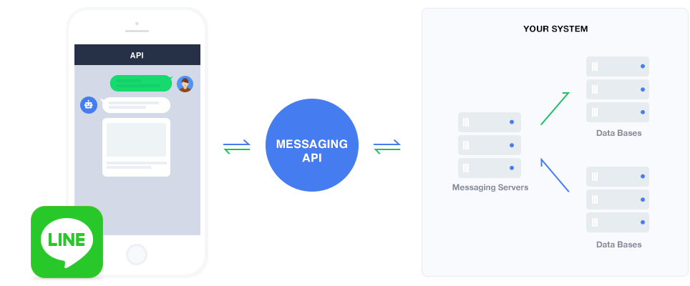LINE Messaging API  
 The messaging API is two-way communicator between your service and your customers by using JSON APIs requests to relay data between LINE app and user’s server through LINE’s server. Messaging API contains 2 types of API:  
  
 First, Push API will let users to use a bot to sends messages to users directly whenever they want. And reply API allow users to respond to messages from customers within a fixed number of seconds.

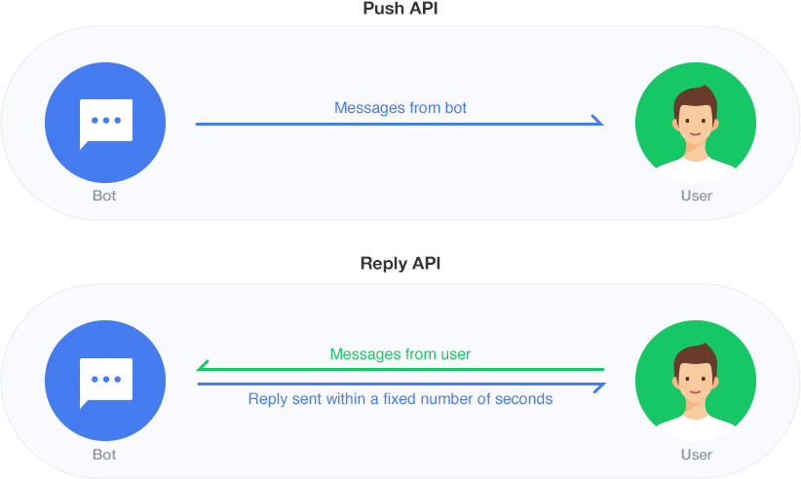  
 Messaging API works on both 1-on-1 conversation of who added or followed user’s service account and group messaging if they have added user’s account in their group.

Architecture concept of messaging API is to give customers better experience as they can feel like they’re interacting with a friend. First, user’s server is linked to LINE platform. Then, if there is a customer interact with user’s service account LINE Platform will split those interactions into 2 types: message (react to messages) and operation (react to an action performed by customers).   
 After that, information is sent to registered URL by using HTTP then JSON string is generated. Note that JSON string varies depending on type of operation. Then, all requests include a signature in the header to let the servers verify that this request is sent from LINE platform or not.  
  
Source:   
Internet Marketing, Stephen Baker, Koros press limited, London, UK, 2014.  
https://business.line.me/en/services/lineat  
https://developers.line.me/messaging-api/overview  
http://www.mga.co.th/viewnewsletter.php?id=213